Dataset – 2018 (INDUSTRIEBETRIEB_1) RPN, 28/08/2020

**Summary**

* Some anomalies are visible directly from time lines
* Quantification partly possible
  + *Correlation Factor*
    - weekly rolling correlation (1 vs 2, 2 vs 3, etc.) seems to be more sensitive than correlation against average (1 vs avg, 2 vs avg, etc.)

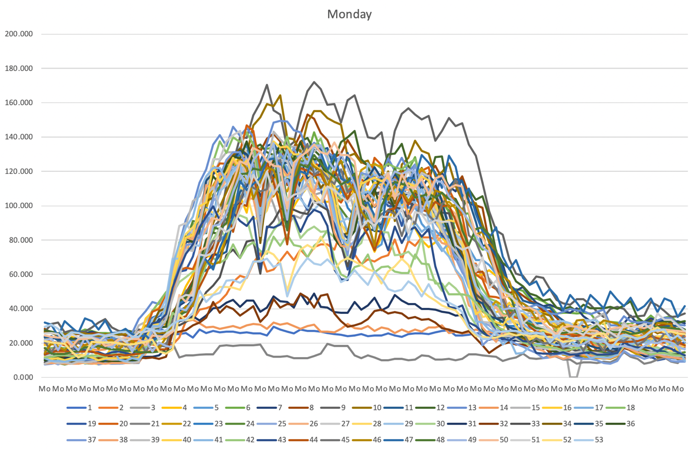

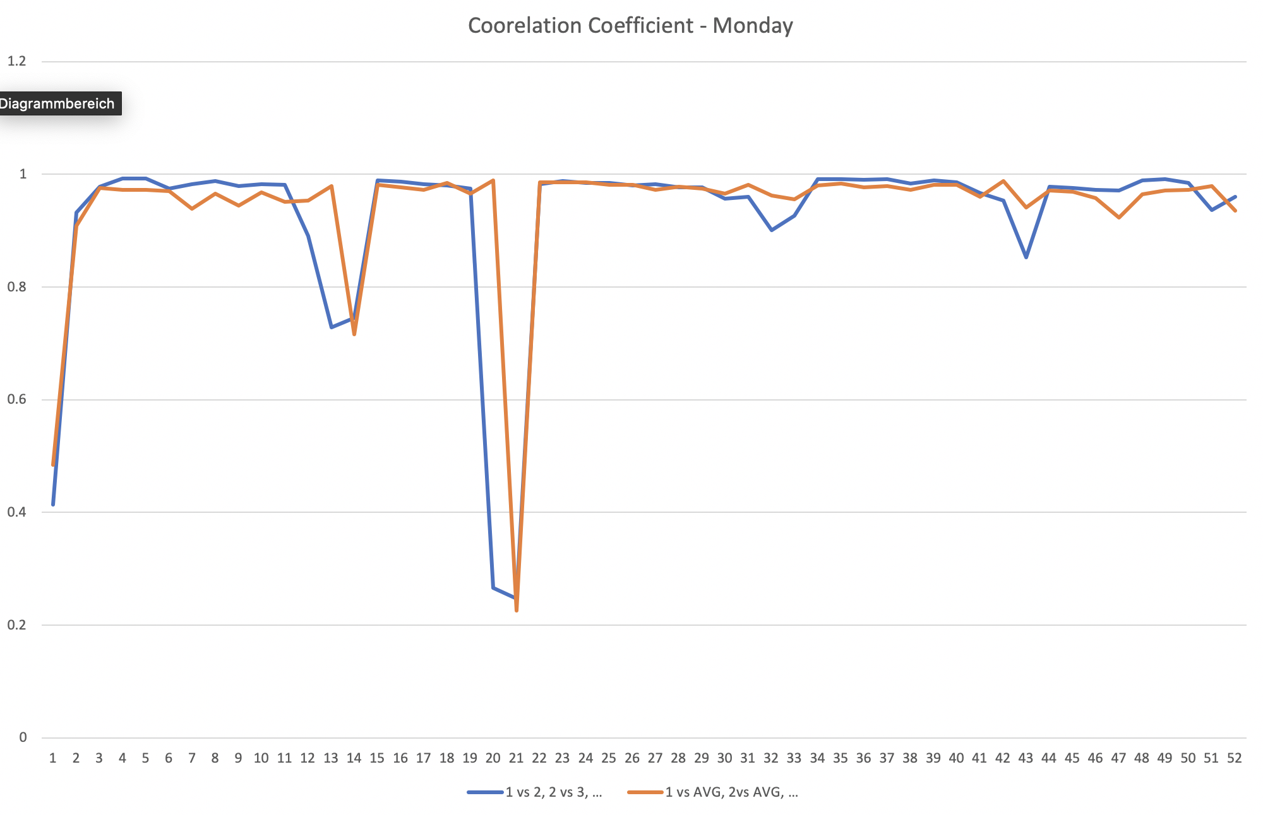

1 vs 2, 2 vs 3, etc. = Correlation of current weekday with previous week

1 vs AVG, 2 vs AVG, etc. = Correlation of current weekday with overall average

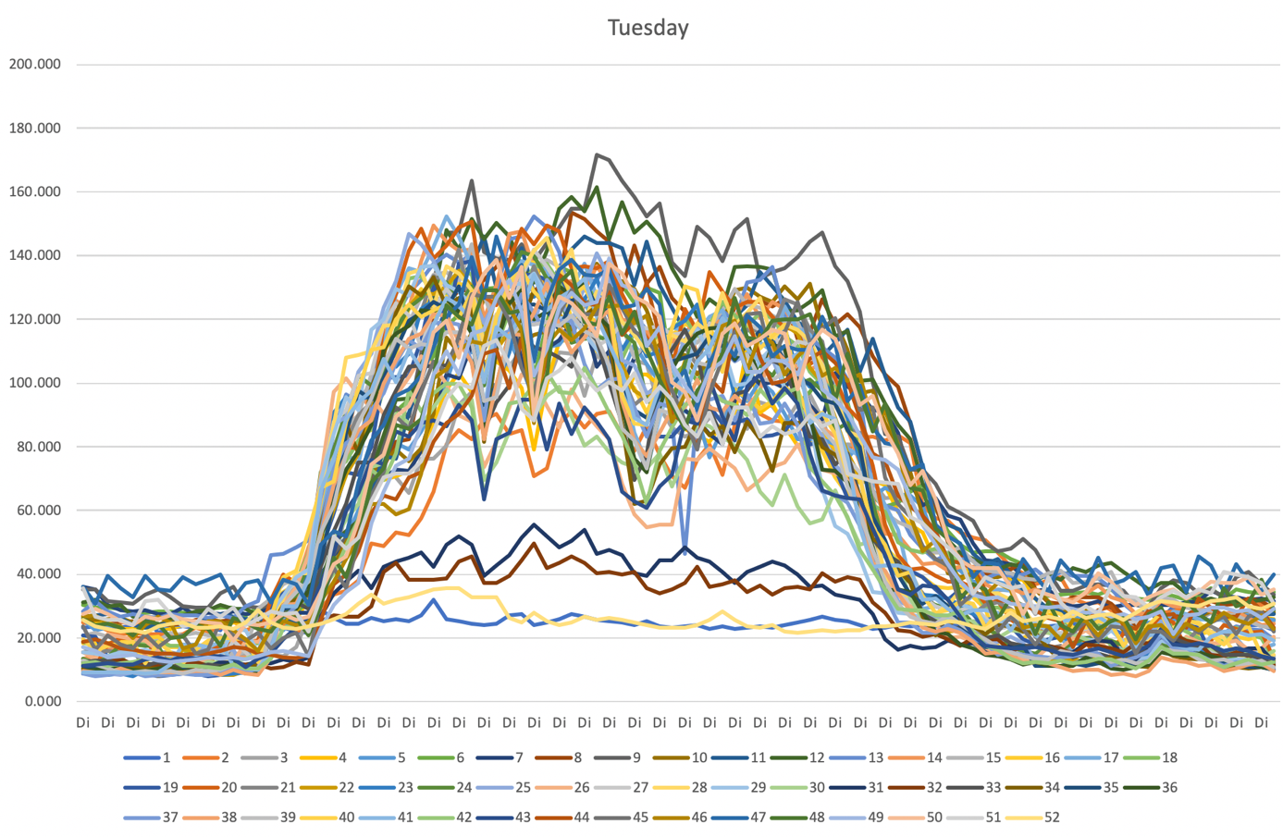

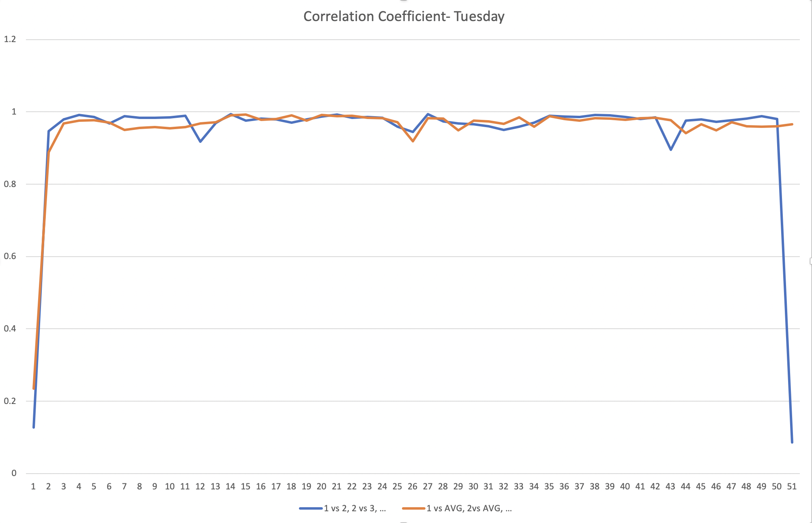

1 vs 2, 2 vs 3, etc. = Correlation of current weekday with previous week

1 vs AVG, 2 vs AVG, etc. = Correlation of current weekday with overall average

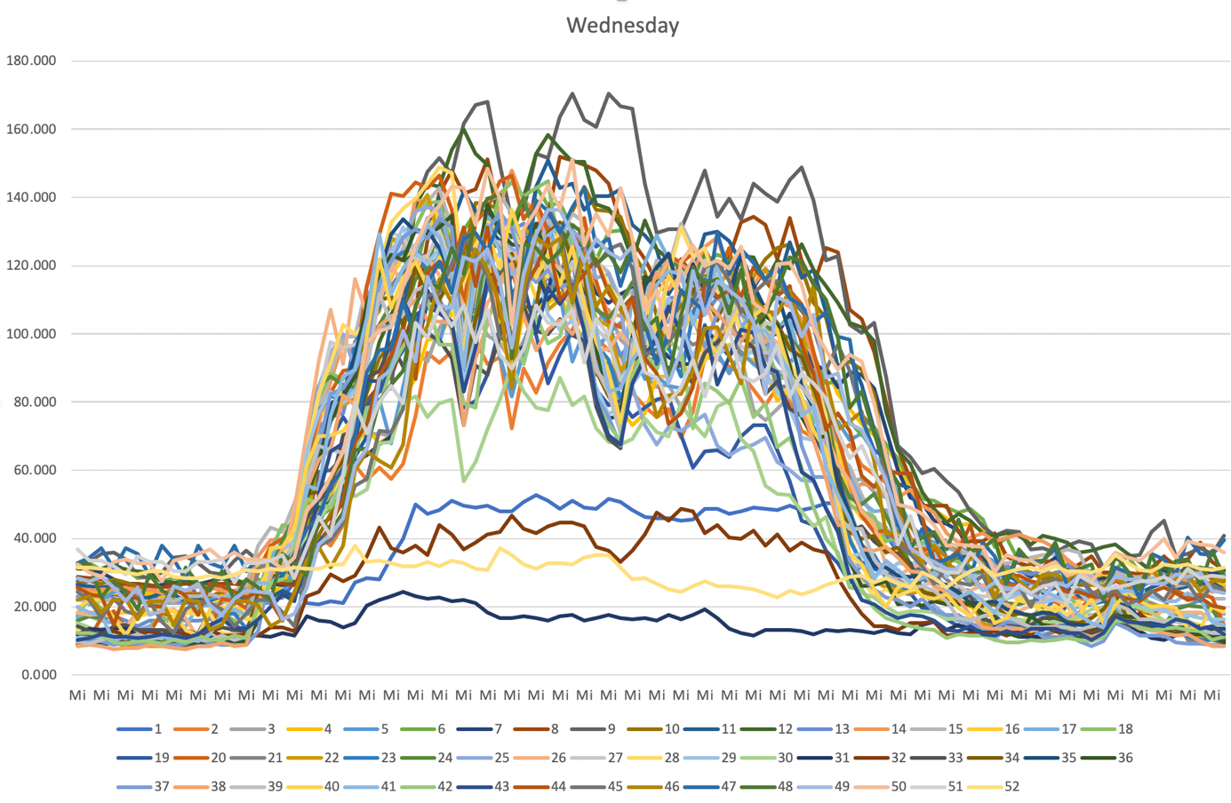

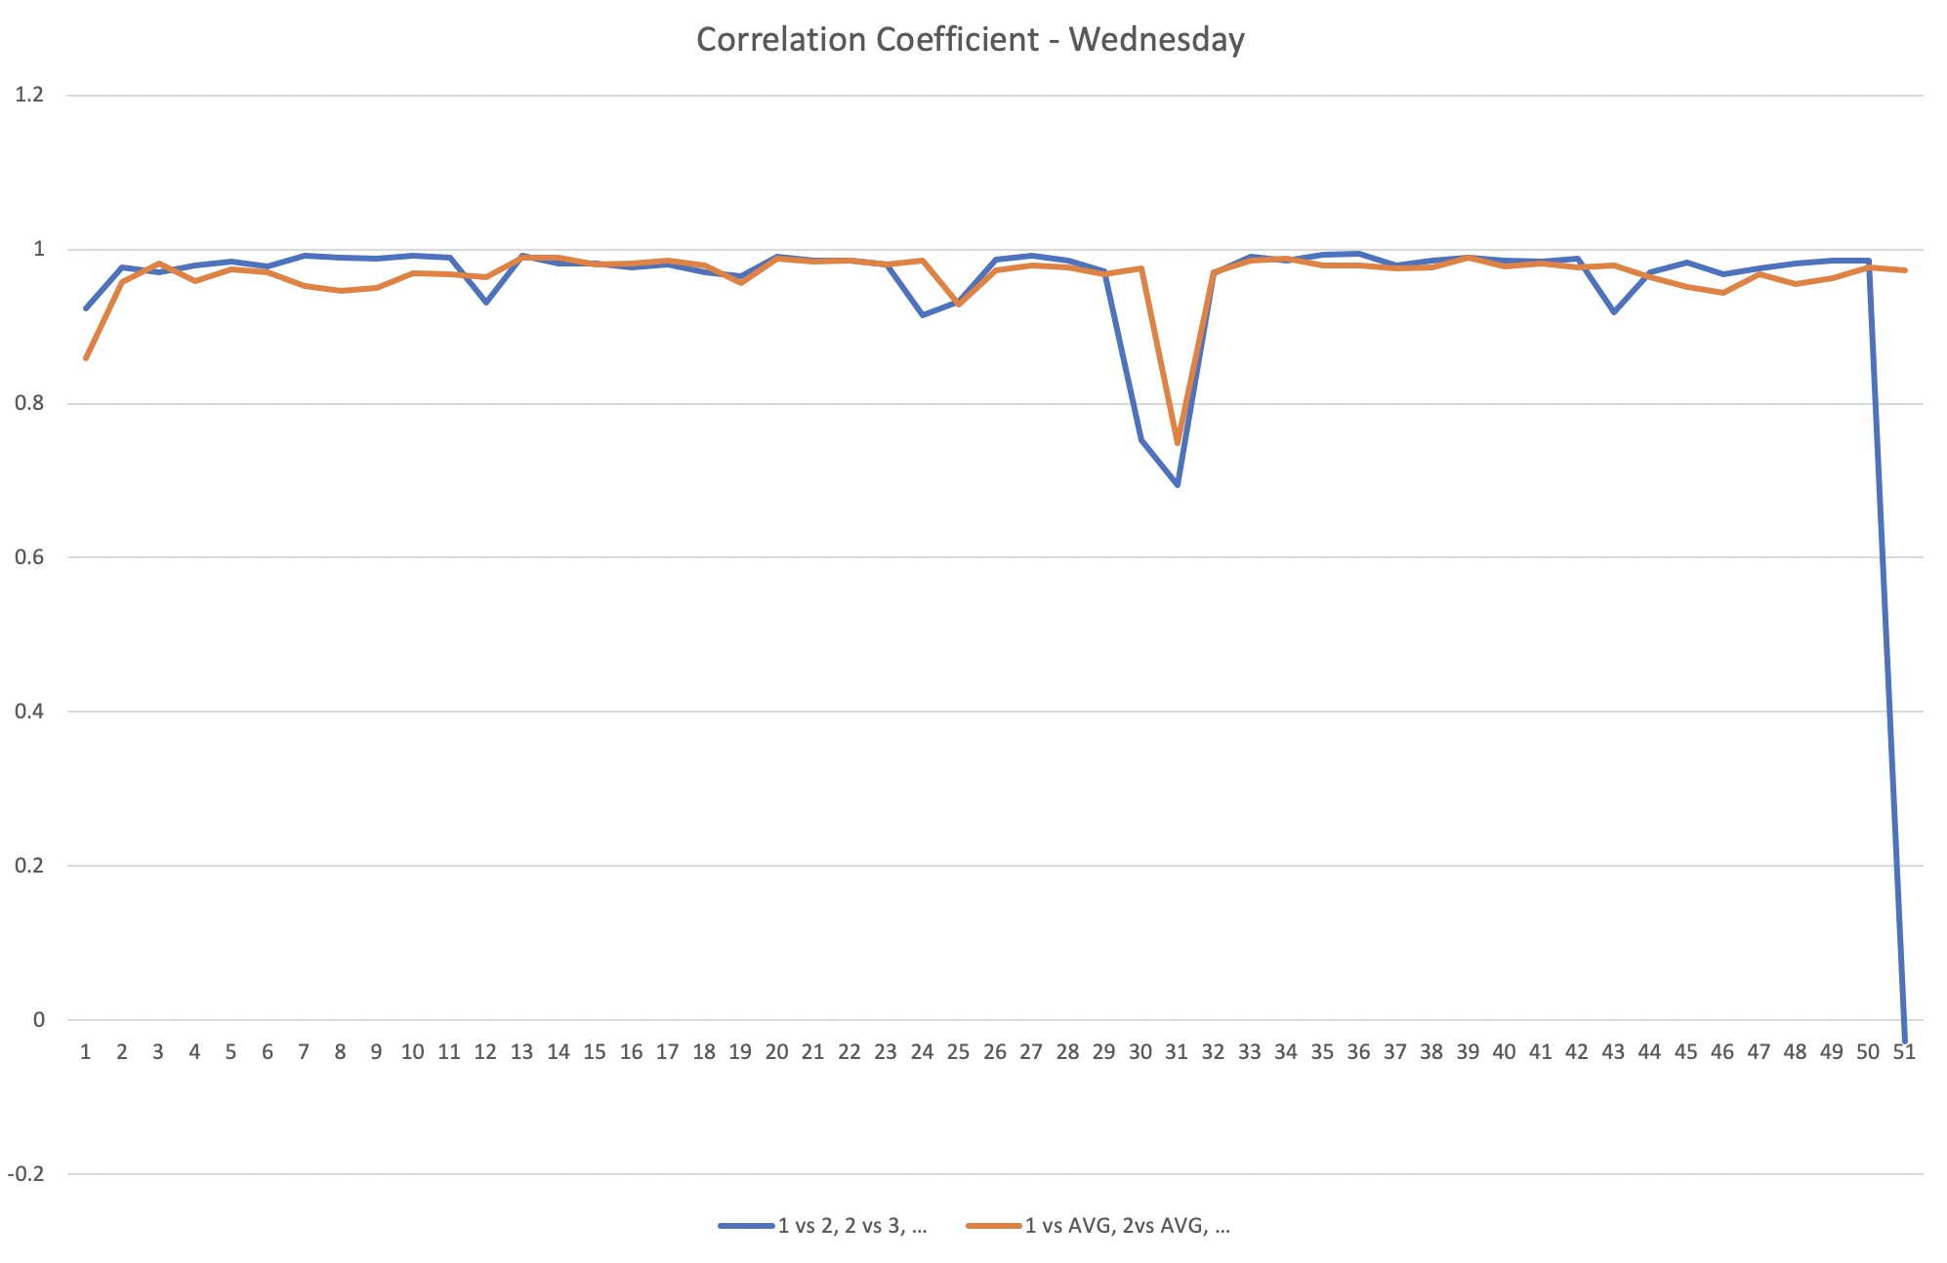

1 vs 2, 2 vs 3, etc. = Correlation of current weekday with previous week

1 vs AVG, 2 vs AVG, etc. = Correlation of current weekday with overall average

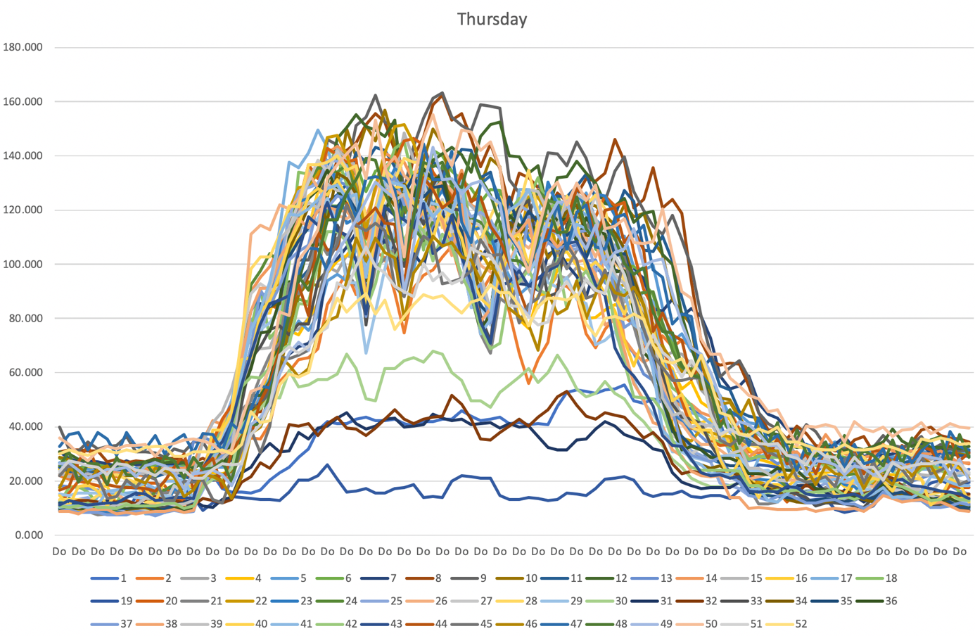

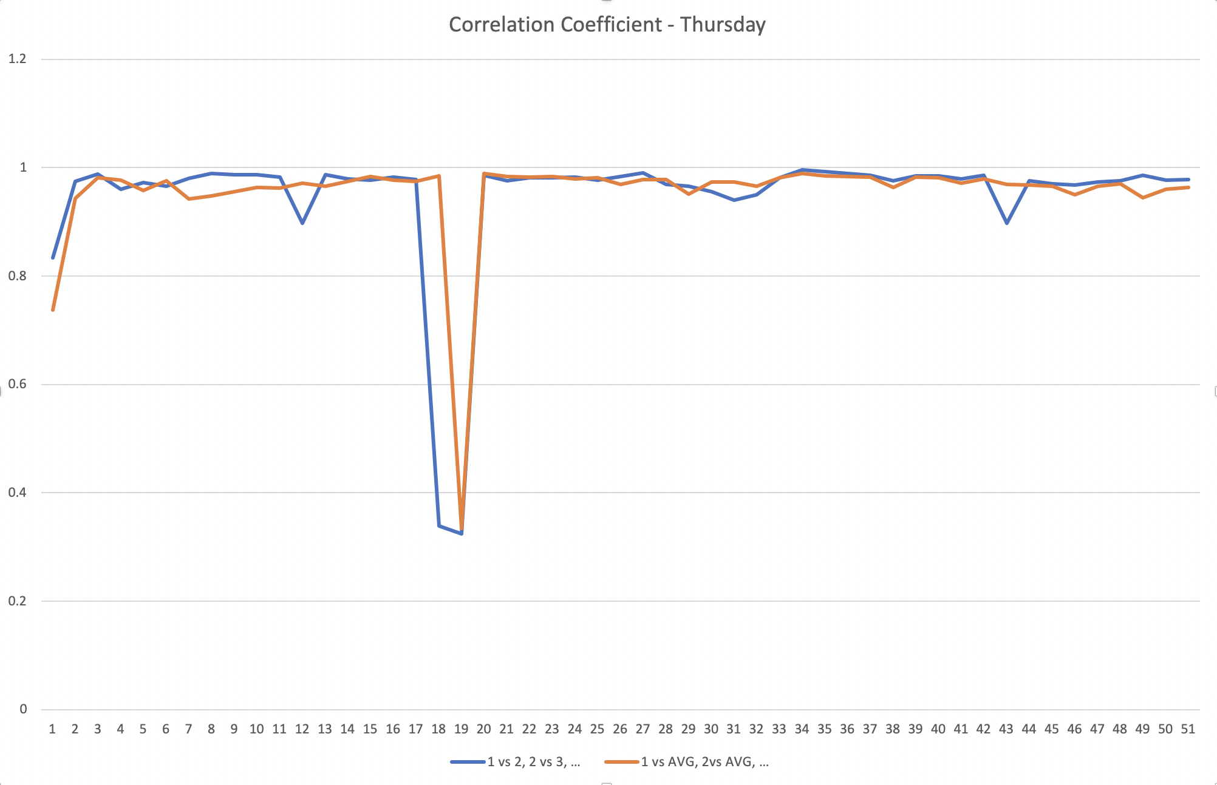

1 vs 2, 2 vs 3, etc. = Correlation of current weekday with previous week

1 vs AVG, 2 vs AVG, etc. = Correlation of current weekday with overall average

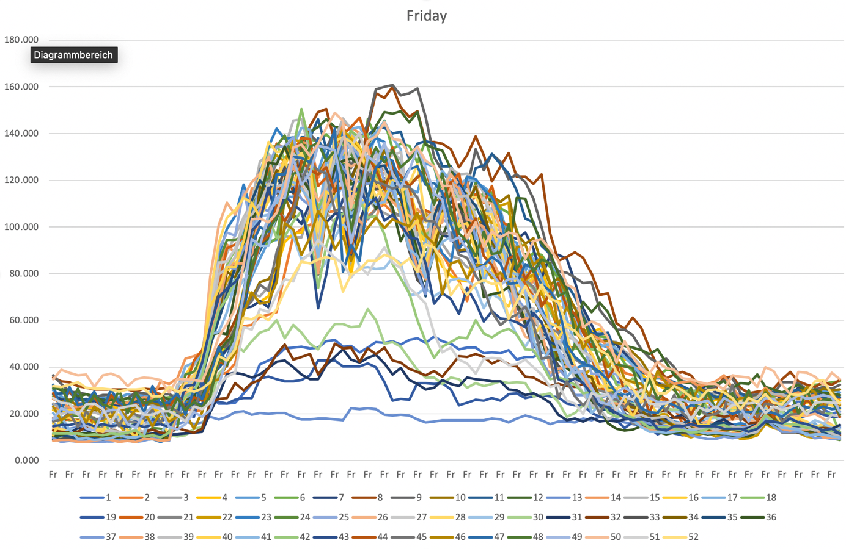

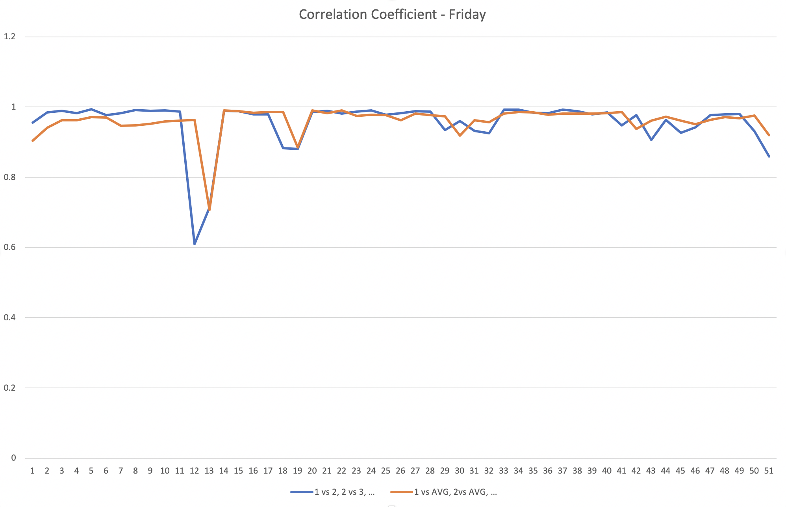

1 vs 2, 2 vs 3, etc. = Correlation of current weekday with previous week

1 vs AVG, 2 vs AVG, etc. = Correlation of current weekday with overall average

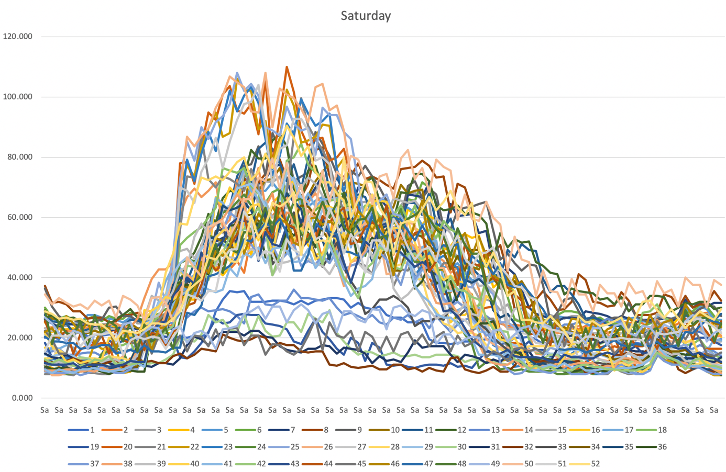

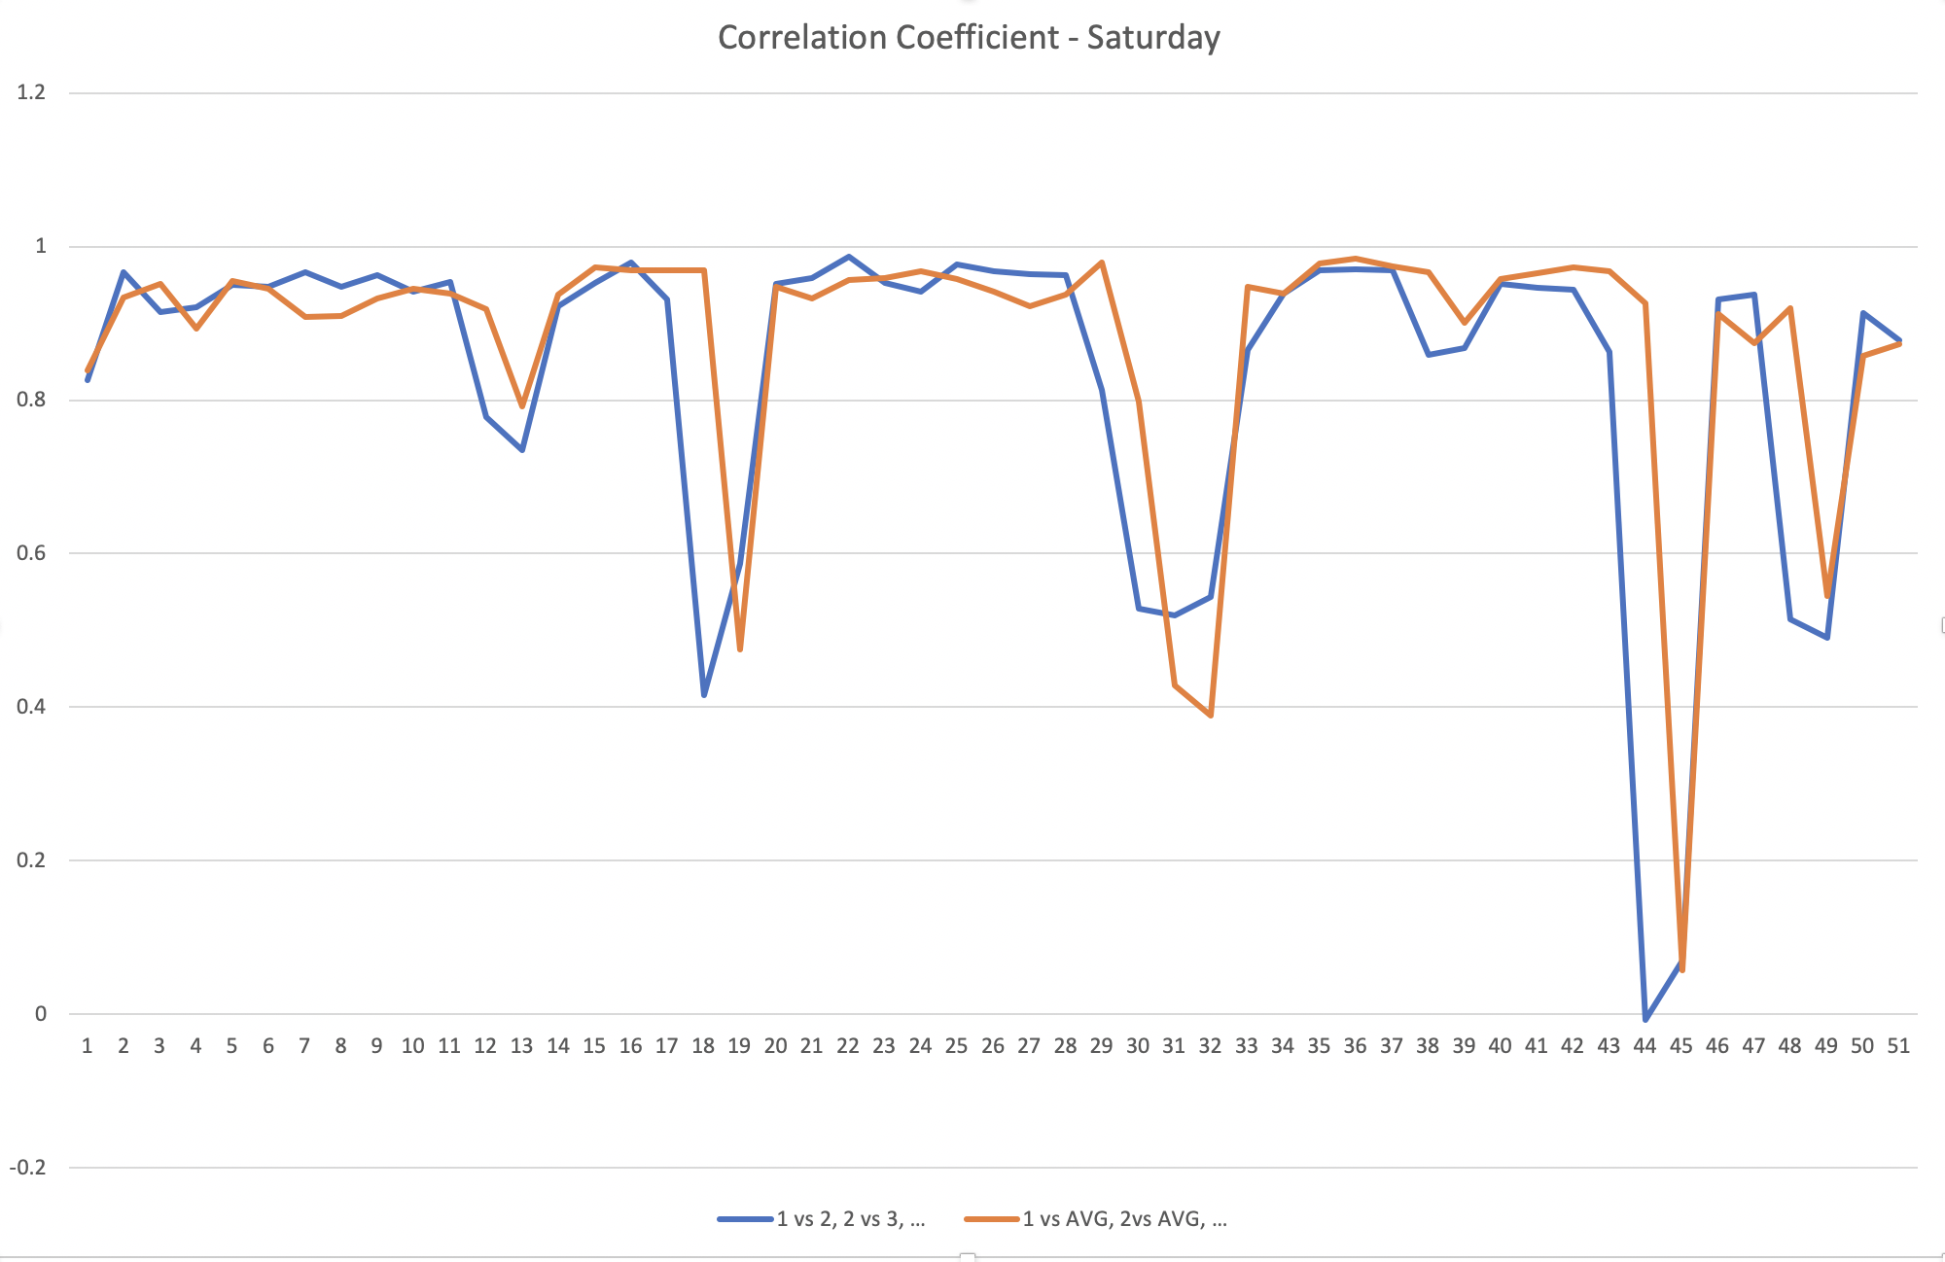

1 vs 2, 2 vs 3, etc. = Correlation of current weekday with previous week

1 vs AVG, 2 vs AVG, etc. = Correlation of current weekday with overall average

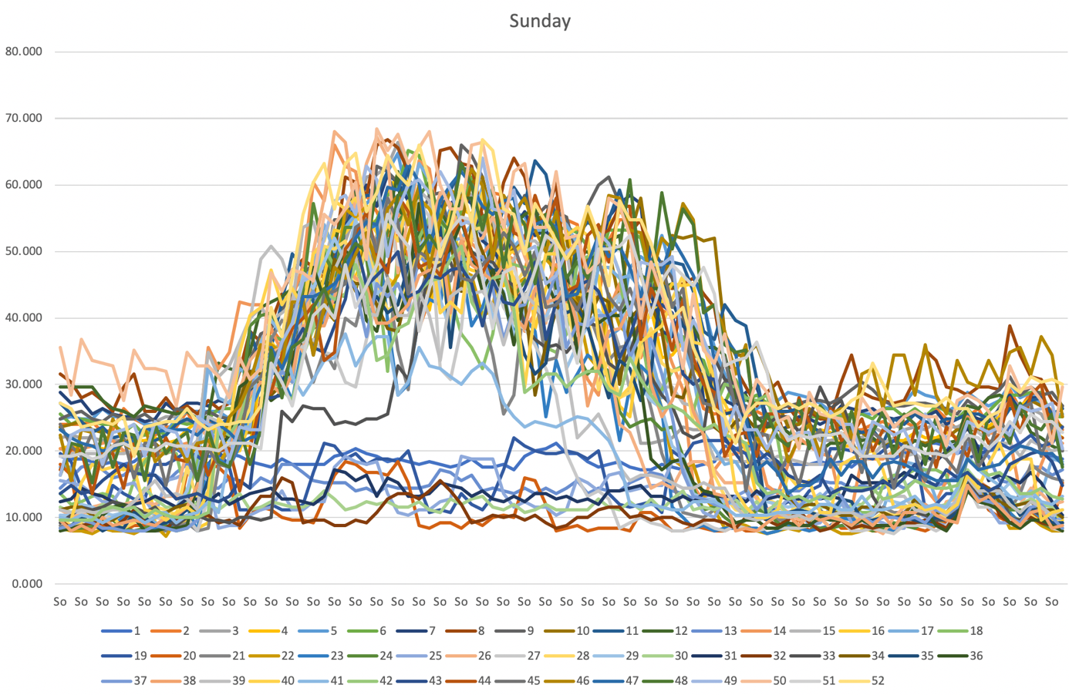

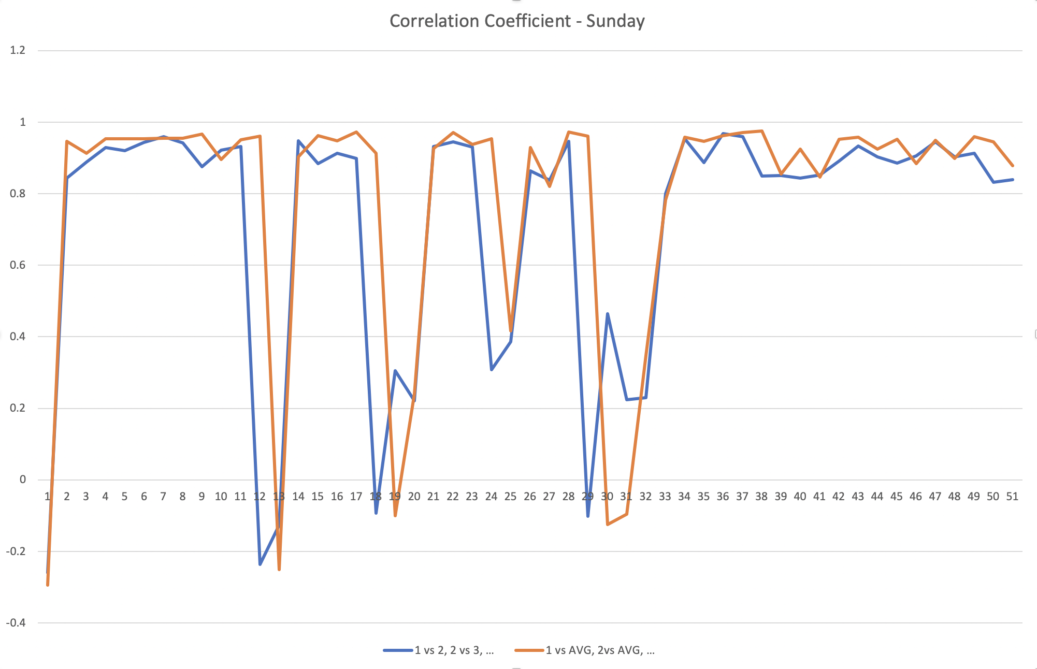

1 vs 2, 2 vs 3, etc. = Correlation of current weekday with previous week

1 vs AVG, 2 vs AVG, etc. = Correlation of current weekday with overall average

